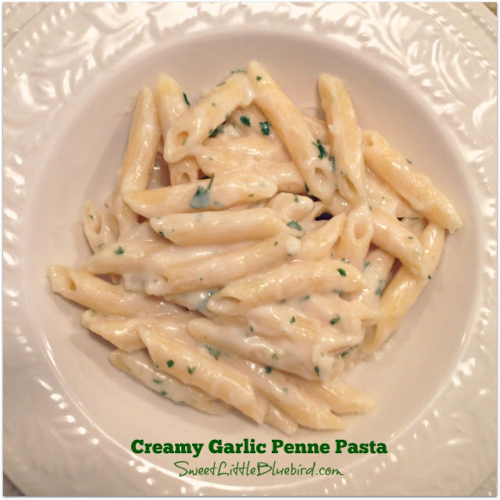
Creamy Garlic Penne Pasta

Prep/Cook Time 30 min
Ingredients
¼ cup salted butter
5 cloves of garlic, minced
4 Tbsp flour
1½ cups chicken broth
1½ cups whole milk
2/3 cup fresh grated Parmesan cheese
Directions
- Melt butter in a medium size saucepan over medium heat. Add garlic and cook for 1½ minutes.
- Add flour and cook for 1½ minutes, stirring continuously.
- Slowly add milk and chicken broth, stirring continuously, until sauce begins to boil and thicken.
- When sauce thickens, add Parmesan cheese and blend until cheese has melted.

Notes
Serve along side or toss with precooked veggies, chicken or seafood

